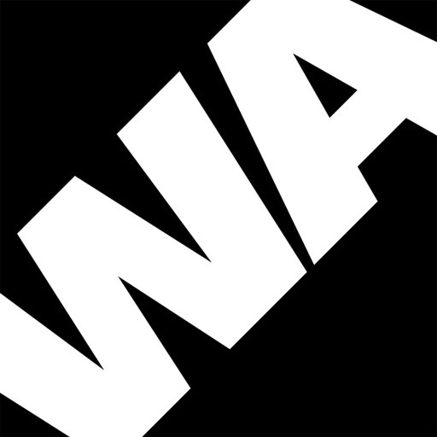

Application Form Questions

- Why do you want to work for Wac Arts? What interests you about the role?
Maximum of 250 words

- Outline how your skills and experience meet the job description and person specification.
Maximum of 250 words

