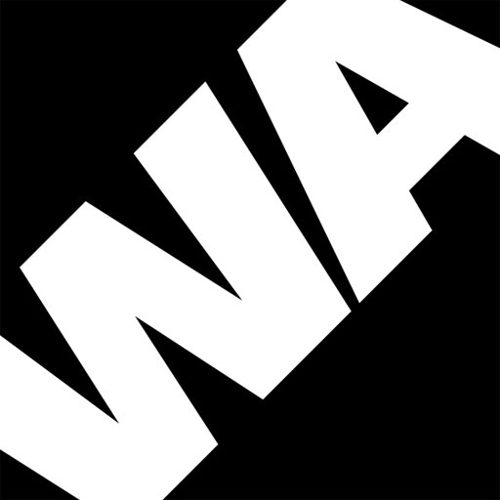

Application Form Questions

- Why would you like to take this role with Wac Arts? What excites you about working with an arts organisation?
Maximum of 250 words

- What skills and attributes do you think you’d bring to the role (please refer to the job description)?
Maximum of 250 words

- What are the key elements, do you think, that are needed to effectively manage and coordinate various tasks in an environment which has ever changing priorities?
Maximum of 250 words

